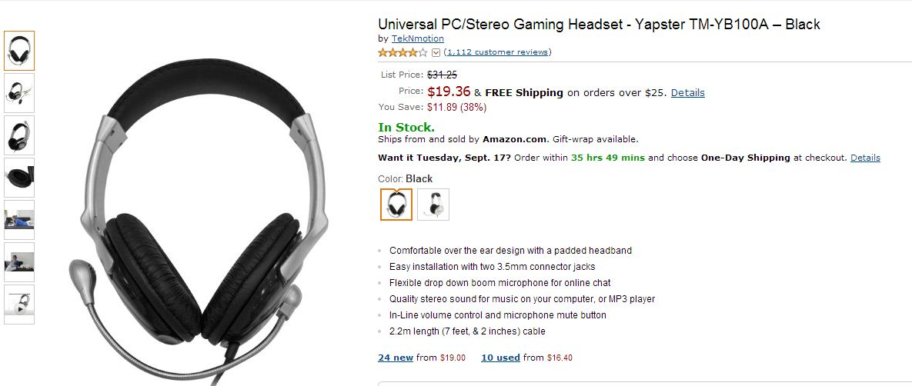

Universal PC/Stereo Gaming Headset - Yapster TM-YB100A – Black
by TekNmotion
4.0 out of 5 stars

List Price: | $31.25
Price: | 133.584 EGP  $19.36 & FREE Shipping on orders over $25.
You Save: | $11.89 (38%)
In Stock.
Color: Black
- Comfortable over the ear design with a padded headband
- Easy installation with two 3.5mm connector jacks
- Flexible drop down boom microphone for online chat
- Quality stereo sound for music on your computer, or MP3 player
- In-Line volume control and microphone mute button
- 2.2m length (7 feet, & 2 inches) cable

LE 20.0 M Pixel USB 6 LED Webcam Mic PC Laptop Camera
by Lucky Electronics
3.7 out of 5 stars
Price: | 28.359 EGP  $4.11

In Stock.

Product Features
- Built-in microphone
- High performance with special designed 5-layer optics lens
- Designed for both laptop and desktop
- Advanced video-phone technology
- With a clip stand

Technical Details
- Brand Name: Lucky Electronics
- Model: TOOGOO

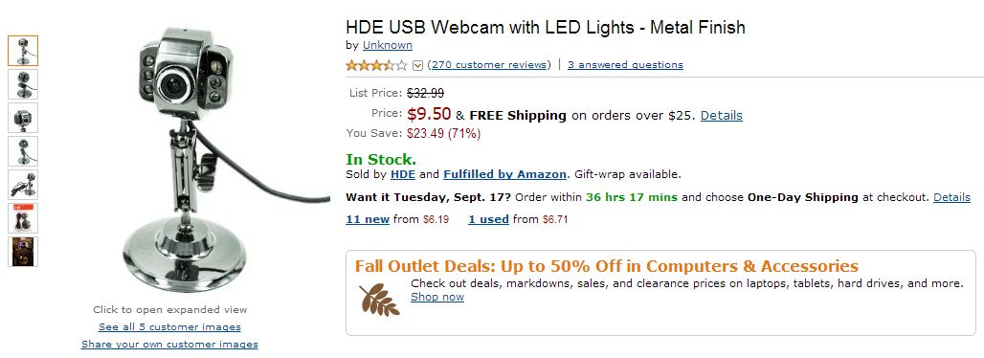

HDE USB Webcam with LED Lights - Metal Finish
3.3 out of 5 stars
List Price: | $32.99
Price: | 65.55 EGP  $9.50 & FREE Shipping on orders over $25. Details
You Save: | $23.49 (71%)

In Stock.

Product Features
- Adjustable webcam base and head, with 6 LED lights
- Connects via USB (cable included)
- Built-in microphone
- Great for Skype, Yahoo Messenger, AIM, video conferencing
- 5 Megapixel

Technical Details
- Brand Name: Unknown
- Model: PWC-160-2MX-p
- Item Package Quantity: 1

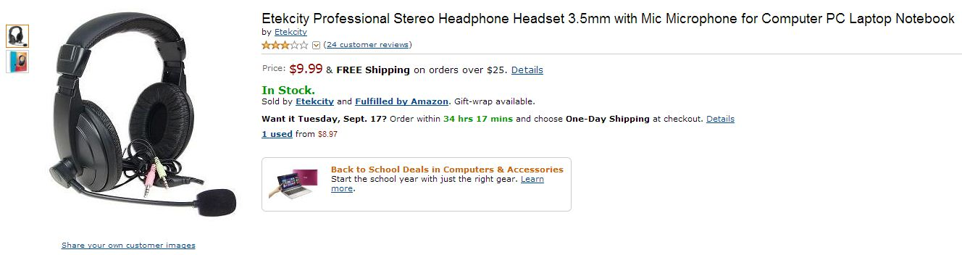
Etekcity Professional Stereo Headphone Headset 3.5mm with Mic Microphone for Computer PC Laptop Notebook
by Etekcity
3.2 out of 5 stars
Price: | 68.931 EGP  $9.99 & FREE Shipping on orders over $25. Details

In Stock.
The Etekcity headphones with microphone headset is ideal for video conferencing! With comfortable padded earphones you'll be able to wear these headphones for hours! Have a net meeting or just chat on IM in comfort!
Features:
Black color
Padded headphones
Speaker: 40 mm dynamic type
Impedance: 32 ohms
Sensitivity: 96 db± 4 db
Frequency: 20 - 20000 Hz
Max. Input power: 100 mW
Volume control dial
Cord length: 5.91 feet (1.8M) approximate
Headset Microphone:
Condenser Type Headset Microphone
Omni-Directional polar pattern
Sensitivity: -40 dB ± 3 dB
Frequency: 50 - 1600 Hz
Package Content
Etekcity Headphones with Headset Microphone

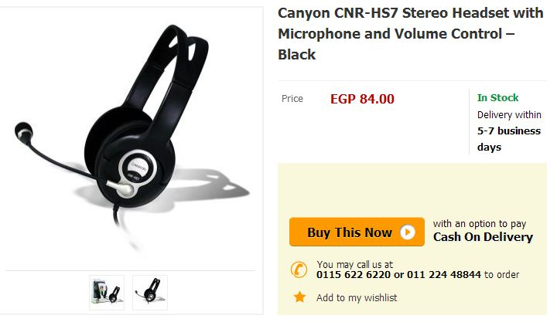

Canyon CNR-HS7 Stereo Headset with Microphone and Volume Control – Black

EGP 84.00
- In Stock
Stereo headset with a flexible microphone and cord-integrated volume control
The CNR-HS7 is a lightweight stereo headset available in black with silver accents. It features soft ear pads and an adjustable headband for a comfortable fit, with a flexible microphone offering a clear sound quality. Ideal for Internet communications, the headset is compatible with Skype, MSN, and other important messaging programs and is suitable for both PCs and notebooks. This headset comes with a cable integrated volume control for your convenience.

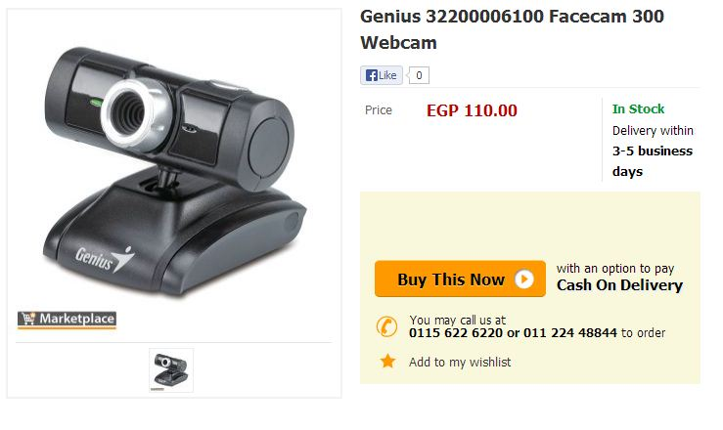

Genius 32200006100 Facecam 300 Webcam
EGP 110.00
- In Stock
Key Features
- OS Support:Windows 7/Vista/XP/Mac
- Max. Still Image Resolution:8M
- Interface: USB 1.1
- Lens Type: MF
Genius introduces its latest VGA webcam. FaceCam 300, which is great for Skype, MSN, Yahoo messenger and instant message communication. You can rotate it 360 degrees and it tilts 70 degrees up and down, and the universal clip fits easily to a LCD or notebook .The CrazyTalk Cam Suite software provides for real time chatting and recording video to upload to YouTube or Facebook.. FaceCam 300 is a very easy to use VGA webcam. For more information, contact your local retailer for more details.
Specifications:
- OS Support: Windows 7/Vista/XP/Mac
- Max. Still Image Resolution: 8M
- Interface: USB 1.1
- Lens Type: MF

