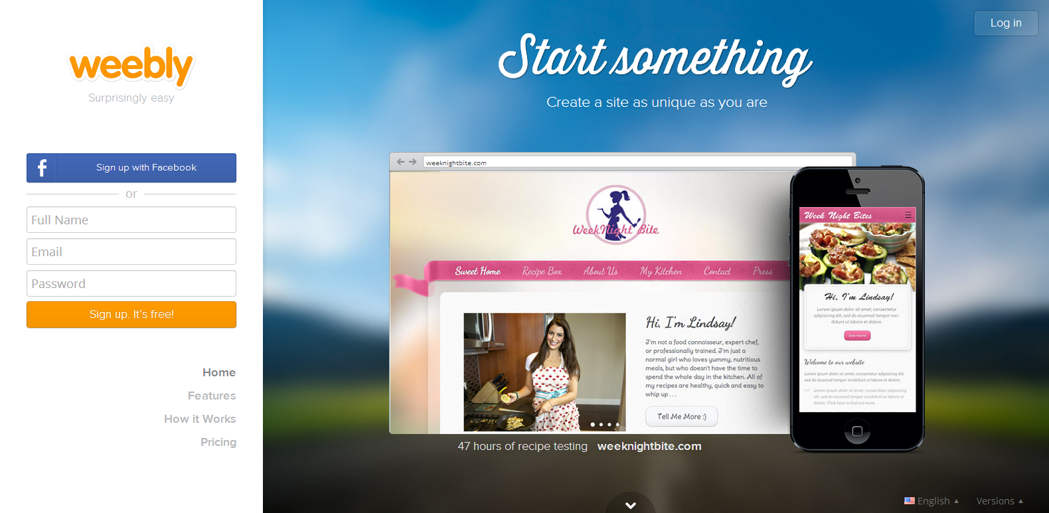
First go to the Website in this case it is (Weebly.com)

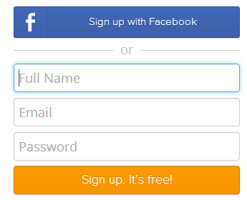 Then go to the signup area (most site now have them on their home), but if not then try finding the signup button (usually next to the LOGIN button)
(NOTE)
Some websites now give you the option to create an account with your Facebook account and you don’t have to worry about the signup, But if that is not the case then this is what you should do.

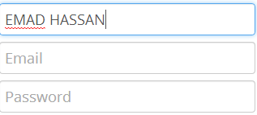On weebly it asks that they give your full name

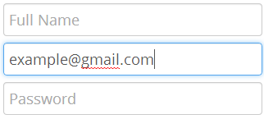 Then it asks for your email so you give it to them (any email works)

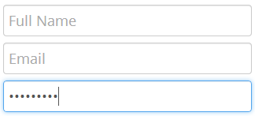 Lastly it asks for a password most website give you direction for the type of password they want but in this case it doesn’t

After following all the directions above CLICK on the Sign up Button.
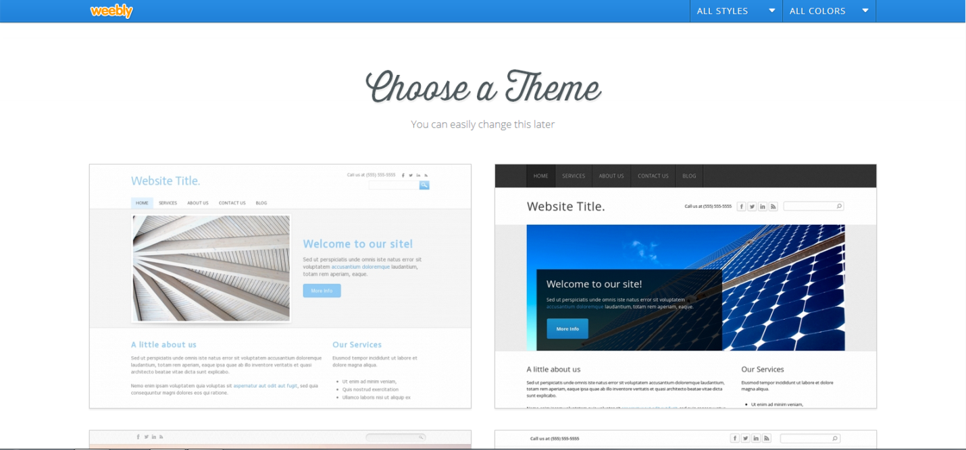
Once you have signed up the website will send you to another page for more information it needs from you. In this case Weebly is asking you to choose a theme( you can change this a you like later)
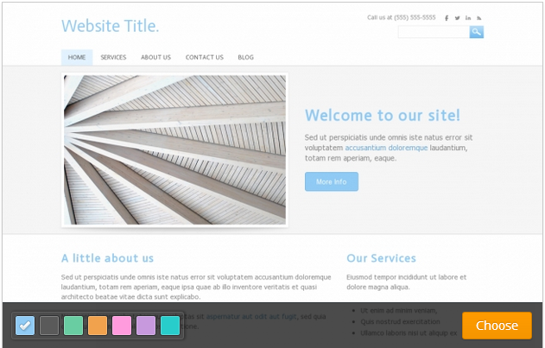
You can also choose the color you want your website to be too. Don’t worry you can also change that later as well.

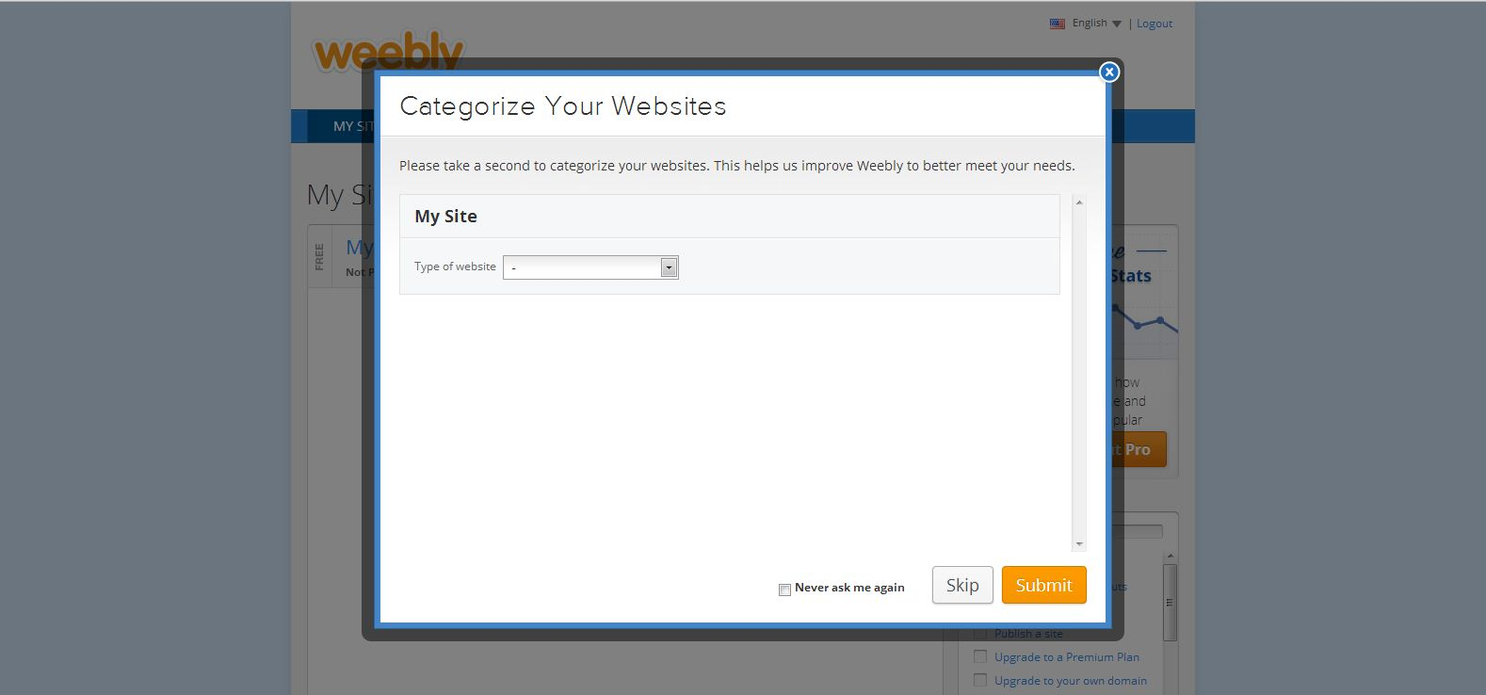
Once you choose the design and color this page will pop on to your pc.
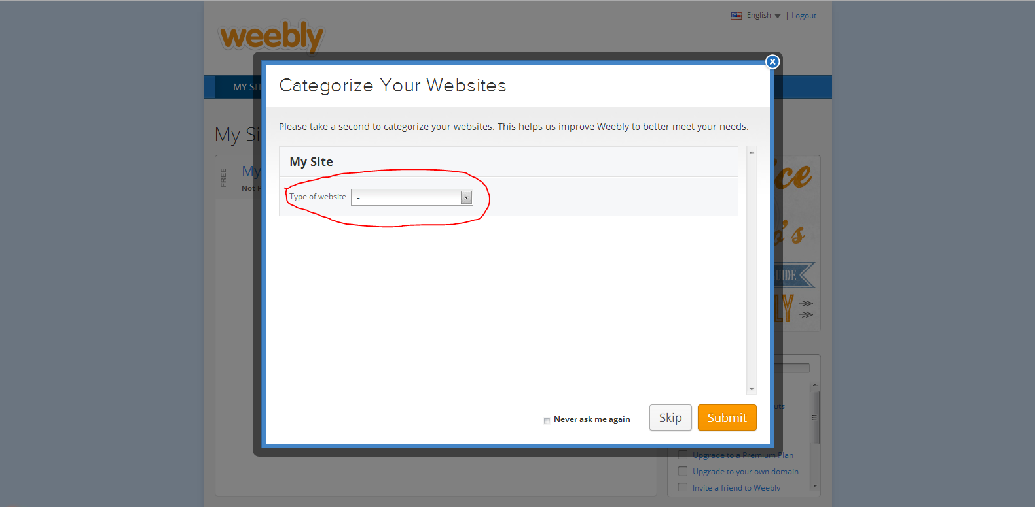
In this page it asks you to choose what type of website you’re going to make. If you don’t want to do this, then just press SKIP.
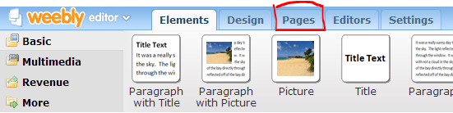
Once your do with the perverse step you will enter you website editing page at the top left corner you will if a tab marked "pages" to create addition pages go to is tab
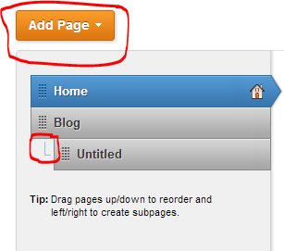 once it loads you will find a table with all your pages on the left side on top of that there is an "add page" button there are several kinds of pages to what need you might want for them as you see here I have the HOME page while is the default and I added a blog page so I can blog. About the subsection, all you need to do to make a drop down tab it to click and drag the page you what to have as a drop down under the page and push it slightly to the right.
You can also name you page by clicking on the page in the table and writing its name in the page name area.
To post a blog entry you go to your blog page and click on the new post.

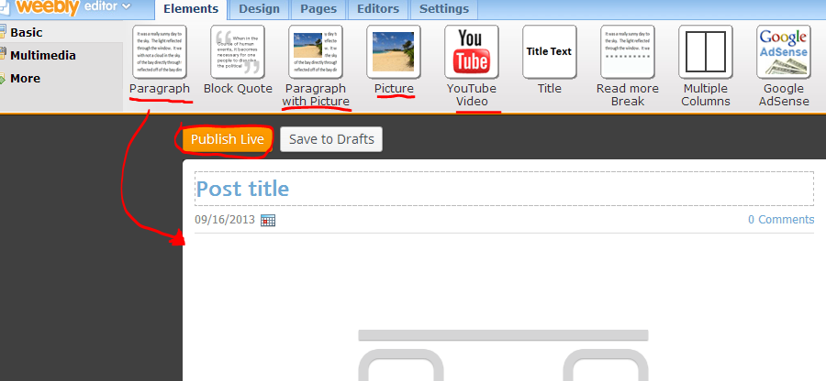
All you need to do is drag the item you want and write your blog. After your done and happy with it click on the publish live button to post it on your website.
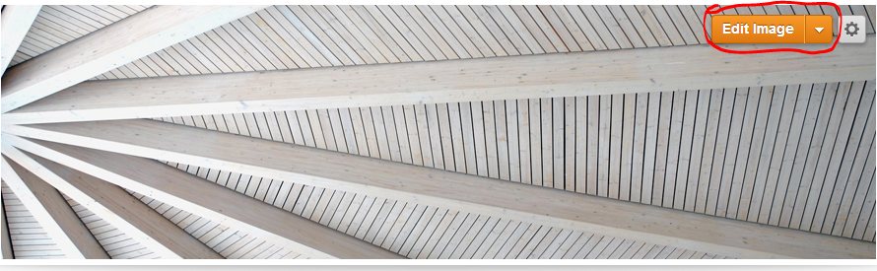
To change your header image scroll you mouse over the image and a button labeled EDIT IMAGE will appear click on it.
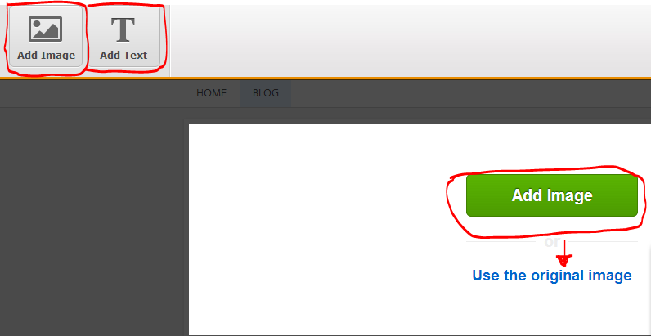
You can click "ADD Image" to put the image you want and you can also add text.
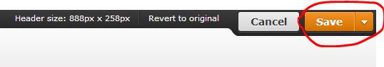After you add your image click on the "save" button on the top right corner
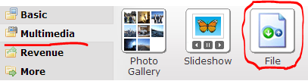 if you want to add a file go to the Multimedia tab on the top left corner and drag the file tab to the page you want it to be on.

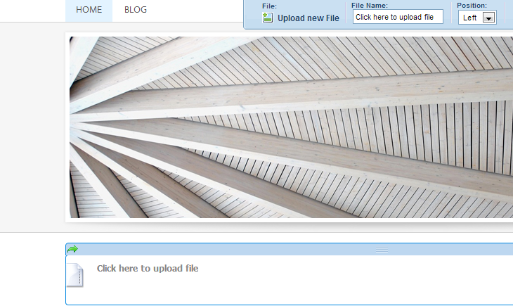
Once you have dragged it on to the page upload the file you want

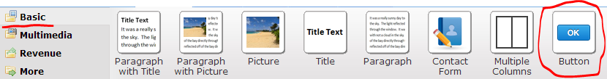
To add a link, go to the “basic” tab and drag the “button” tab
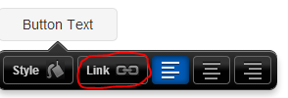scroll over the button and then click on the link tab to and the link
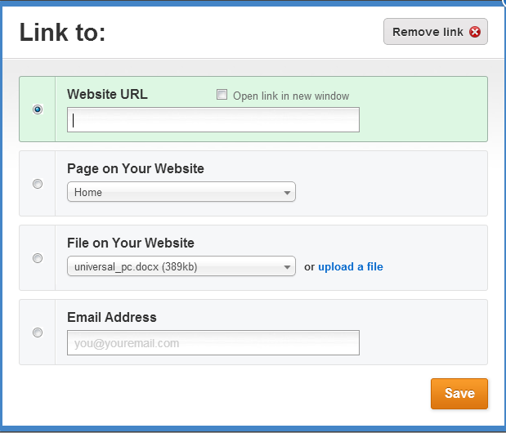
You can put the URL of a website or other stuff as well.
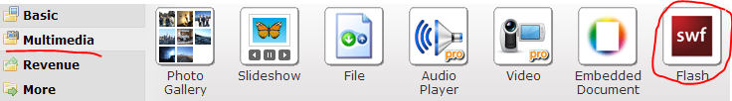To add flash components just do the same thing you did with the file tab
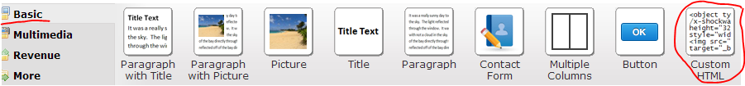you can also customs your website using HTML with is in the “basic” tab
You can find commands here to help you
http://www.bios.niu.edu/johns/bioinform/htmlcom.html
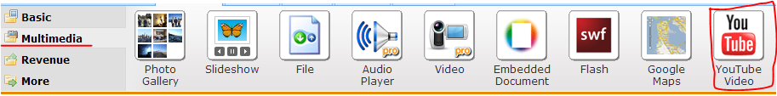
To add YouTube video, do the same with the “link” drag and put the URL of the video
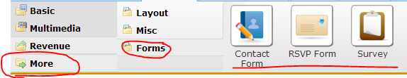
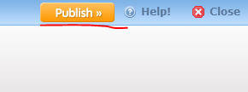
You can also make survey, forms, and contact list by going to moreformsand choosing what you need
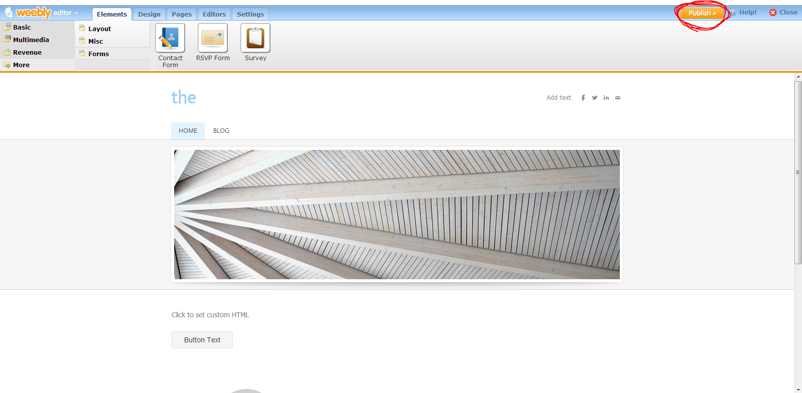
After you are happy with your changes all you need to do is click on PUBLISH and it will upload your website with all the changes on the internt.

